# DECLARATION

I, ……………………………………………. declare that:

1. The research reported in this dissertation, except where otherwise stated, is my original work.
2. This dissertation has not been submitted for examination for any degree at this or any other university.
3. This dissertation does not contain other persons’ writing, data, pictures or graphs except where acknowledged as having been sourced from the other persons. Where written sources have been used:
4. The words have been paraphrased and the information attributed to the source through referencing;
5. With exact words quoted, the writing has been placed in quotation marks and referenced.

**DECLARATION OF COPYRIGHT**

I hereby grant permission to the National University of Science and Technology Library to reproduce copies of this dissertation and to lend or sell such copies for private, scholarly or scientific research purposes only.

I reserve other publication rights. No extensive extracts from this dissertation may be printed in any form or otherwise reproduced without my written permission.

**SIGNATURE: …………………………………**

**PERMANENT ADDRESS: …………………………………………….**

**……………………………………………..**

**PLACE NAME**

**DATE: ..............................................................**

# DEDICATIONS

This project is dedicated to my family especially my mother and father.

# ACKNOWLEDGEMENTS

# ABSTRACT

Water balance is essential for high quality yields. Under-wateredcrops suffer from nutrient deficiencies while over-watered plants are more prone to diseases and can lead to root death through suffocation. Also over-watered plantsare not able to withstand dry spells during dry season. Water-saving agricultural practices and sound watermanagement strategies are therefore required to ensureviability of the farming industry.

With great advancements in Internet of Things and Artificial Intelligence its high time we leverage the beauty of these technologies in Zimbabwe as it answers to most of the challenges we are facing. Reduction in production costs through automation of manual tasks, remote monitoring, high output yields and better land fertility are some of the advantages of applying these technologies into farming.

This study is aimed at developing a smartirrigation controller which acquires soil moisture contents, temperature, humidity, volume of water used and whether it’s raining or not. The controller cleans the signals, stores to a local database before storing to an online database. Server side JavaScript controller fetches data from the database and feed to a dynamic neural network which responds with predictions of soil moistures for the coming days to the irrigation controller and decisions can be made to best optimize water to be irrigated. The controller is able to send SMS and email notifications to the farm operators. This data is also relayed to aweb application where it can provide valuable information to any operator concerned and can remotely control the irrigation processes.

The heart of the controller circuit isthe WeMos atmega2560 based micro-controller that uses C++ as a high level programming language. Message notifications are achieved by interfacing with sim800L GSM module. The dynamic neural network is made from MATLAB neural network toolkit.

# TABLE OF CONTENTS

DECLARATION ii

DEDICATIONS iii

ACKNOWLEDGEMENTS iv

ABSTRACT v

TABLE OF CONTENTS vi

LIST OF FIGURES vii

LIST OF TABLES viii

CHAPTER ONE - INTRODUCTORY CHAPTER 9

1.0 Introduction 9

1.1 Background 9

1.2 Aim 10

1.3 Objectives 11

1.4 Scope 11

1.5 Justification 11

1.6 Methodology 12

1.7 Timeline 13

1.7 Summary 13

REFERENCES 15

# LIST OF FIGURES

Figure 5.1: Decisions and operations performed for scenario 1 ............................................ 11

Figure 5.3: Sniffer agent results ........................................................................................... 12

# LIST OF TABLES

Table 4.1: Process parameter settings for Experiment 1 ......................................................... 9

Table 4.7: Experiment 2: Effect of mould cooling and heating on the mould temperature .... 10

# CHAPTER ONE - INTRODUCTORY CHAPTER

## Introduction

World climate change is causing a major blow on global water supplies. 70% of world’s fresh water is used for irrigation purposes, it is therefore important to develop and leverage trending technologies to monitor and control agricultural fields for sustainable and efficient water use. Irrigation should meet specific plant water demands to avoid overand under irrigation. This can be attained by performing irrigation operations basing on the forecast of soil moisture contents, time. Precision irrigation aims to find and quantify plant water needs in a smart way. This field of study is very helpful in estimating farming parameters like fertilizers and other input needsby assessing soil conditions, thus preventing inflexiblepractices in farming. The irrigation amount and timing is based on measurementsof soil, plant, and climatic variables from which the plant water need is inferred. Precisionirrigation has been shown to improve water use efficiency, reduce energy consumption, and enhancecrop productivity by leveraging advances in sensor, control.Such advances include the development of energy efficient and fault-tolerant wireless sensornetworks, intelligent proximal sensing for the detection of plant water stress, and variablerate irrigation systems.

Soil moisture predicting helps in determining the timing ofirrigation

## 1.1 Background

With the drive to rebuild and grow our economy, it is now imperative that we utilize our abundant resources on the agricultural front. Agriculture occupies a central space in the Zimbabwean economy and has the potential to significantly reduce poverty, enhance economic growth and with time entrench economic stability.

According to the Food and Agriculture Organization, 70% of Zimbabwe’spopulation depends on agriculture. Climate change is threateningagriculture productivity and making worse some of Zimbabwe’s key agriculture challenges which arelow soil fertility and reliance on rain fed systems. In 2012, 76% of rural households lived below the poverty datum line and 32%of children under five were stunted as a result of malnutrition

The continuous increase in food demand requires a rapid improvement in food productiontechnologies. Food insecurity is a major challenge in developing countries. In a country likeZimbabwe where the economy is mainly agriculture based, use of technology to improve on yields isparamount.

Most ofirrigation controllers that are locally available are ON/OFFtype and these cannot give optimal results inirrigation costs and crop yield.

Picture below shows a major problem of over irrigation experienced by traditional open loop irrigation systems. Water is wasted, crops become more vulnerable to water borne diseases, land fertility decreases as vital minerals are washed away with excess water and as a result poor yields are experienced.

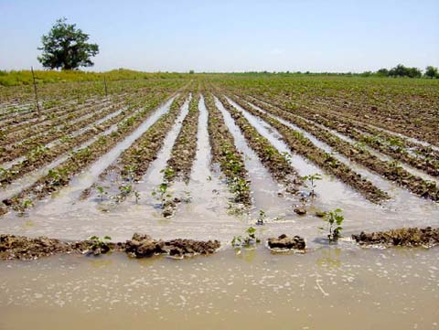

Figure 1Picture showing over irrigated land

## 1.2 Aim

To develop a smart irrigation system that is able to predict soil moisture contents to generate irrigation schedules.

## 1.3 Objectives

* Design an irrigation controller based on AVR micro-controller.
* Design SMS notification interface for remote monitoring.
* Create a Neural Network Model to predict soil moisture contents.
* Design web application to monitor the field.

## 1.4 Scope

*(Gives limit of study/research, i.e. where research will start and where it will end).*

The scope of this project entails the design and implementation of a micro-controller based irrigationsystem driven by a neural network to help on watering scheduling. Also the design of a notification interface which will be sending important data about the field to the farmer via SMS’s. An online dashboard is also going to be made for monitoring and controlling irrigation processes.

## 1.5 Justification

*(Gives the reason why the project has to be done)*

The proposed project will help the country as a whole as it is a step towards minimizing water supply wastages through run-off and evaporation of excess water as a result of over irrigation. Every farmer in Zimbabwe has a goal of producing healthy crops and high yields and this can be achieved by introducing smart technologies which makes use of big data and learning strategies to assist in farming. By doing so, Zimbabwe will gain back its fame in food security. This will reduce manual work of controlling the system, thereby reducing production costs.

it is with no doubt that this technology will be of great help to farmers as it requires few operators in the field to monitor and control

Irrigation is one of the most reliable method of crops production. More land now is being under irrigation and there is a need for optimal use of water. With the great advancement in electronics microcontrollers and microprocessors has been used together with various sensors to gather data and control physical quantities like temperature, humidity, heat and light. Using these technologies automation of processes is greatly increasing. Irrigation systems in crop production can also be automated. The systems help in saving water and thus more land can be brought under irrigation. Crops grown under controlled conditions tend to be healthier and thus give more yields.

Every farmer wants to know what’s happening to the crops so that good decision can be made in time. This projects makes it possible for remote monitoring of soil moisture, outdoor humidity and temperature, volume of water usage.

## 1.6 Methodology

*(Gives the**research methods used)*

In doing research, the following research techniques will be used:

* Gathering data from primary sensors and storing in local and cloud database
* Reviewing software api’s and hardware documentation.
* Literature review
* Secondary information used in the review was developed from mainly journals,  
  internet, hand books, eBooks and books.
* A prediction model will be developed its output is going to be used for control operations
* Fabrication/Building of Hardware System

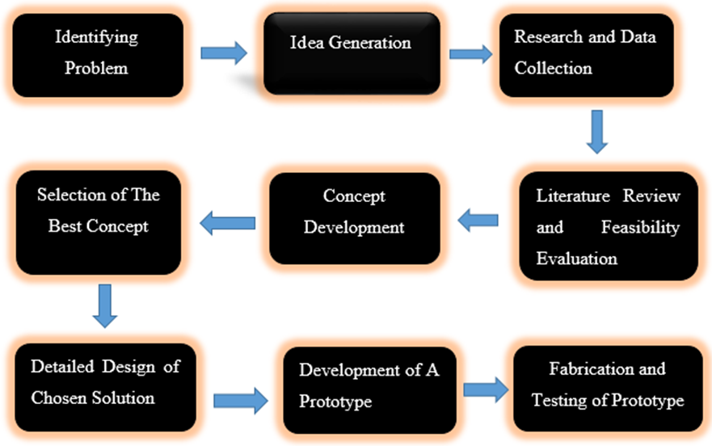

Figure The Design and Development model.

## 1.7 Timeline

*(The important step in completing your project is to pull together a Project Timeline. This timeline should not only consist of a schedule for completing the project, but should identify important milestones, deadlines, and the resources needed along the way).*

## 1.7 Summary

*(Gives the summary of the chapter)*

The proposed project intends to use Artificial Intelligent techniques, which are growing in the field of agriculture and engineering as a whole. By gathering soil moisture values the system will be used to generate irrigation schedules and predict on the soil moisture values for the upcoming days and decisions can be made in time. In doing so, the system will encourage maximum efficiency of water usage and plant growth and healthy. With its capabilities, it will tackle problems related with under and over irrigation and major decisions will be made in time.

# REFERENCES

(Referencing styles to be used are the APA or the Harvard)

**Harvard Style of Referencing Examples**

BRITISH STANDARDS INSTITUTE. (1990). BS5605:1990. *Recommendations for citing and referencing published material*. Milton Keynes: BSI.